**INTI International College Penang School of Computing**

**3+0 Bachelor of Science (Hons) in Computer Science, in collaboration with Coventry University, UK 3+0 Bachelor of Science (Hons) in Computing, in collaboration with Coventry University, UK**

# Coursework cover sheet

**Section A - To be completed by the student.**

|  |  |
| --- | --- |
| Full Name: Lim Sheue Ying | |
| CU Student ID Number: P22014796 | |
| Semester: 2 | |
| Session:  **April 2023** | |
| Lecturer:  **Puteri Nursyawati Azzuri (puteri.azzuri@newinti.edu.my)** | |
| Module Code and Title:  **4067CEM Software Design** | |
| Assignment No. / Title:  **Continuous Assessment** | % of Module Mark:  **50** |
| Hand out Date:  **12 May 2023** | Due Date:  **Task 1: 02 June 2023, by 11.59pm.**  **Task 2: 07 July 2023, by 11.59pm**  **Task 3: 07 July 2023, by 11.59pm.**  **Task 4: 07 July 2023, by 11.59pm.**  **Task 5: 07 July 2023, by 11.59pm.** |
| Penalties: No late work will be accepted. If you are unable to submit coursework on time due  to extenuating circumstances, you may be eligible for an extension. Please consult the lecturer. | |
| Declaration: I/we the undersigned confirm that I/we have read and agree to abide by the University regulations on plagiarism and cheating and Faculty coursework policies and procedures. I/we confirm that this piece of work is my/our own. I/we consent to the appropriate storage of our work for plagiarism checking.  Signature(s): | |

# Section B - To be completed by the module leader

|  |  |  |
| --- | --- | --- |
| Intended learning outcomes assessed by this work:   1. Understand and apply appropriate concepts, tools, and techniques to each stage of the software development. 2. Understand and apply design patterns to software components in developing new software. 3. Demonstrate an understanding of project planning and working to agreed deadlines, along with professional, interpersonal skills and effective communication required for software production.   5. Demonstrate an awareness of, and ability to apply, social, professional, legal, and ethical standards as documented in relevant laws and professional codes of conduct such as that of  the Malaysian National Computer Confederation. | | |
| Marking scheme | Max | Mark |
| 1. User Story Mapping | 20 |  |
| 2. Setting up a GitHub |  |
| Repository | 10 |
| 3. Creating a Class diagram and |  |
| design pattern selection | 30 |
| 4. Creating a Prototype User |  |
| Interface and Usability Testing | 20 |
| 5. Discuss the ethical issue |  |
| related to the software | 20 |
| Total | 100 |  |

Task 3 - Creating a Class diagram and design pattern selection (30 marks)

Create a simple Class diagram which should consists of the Classes that might be used to represent the system and the association between them. You don’t have to declare the attributes and operations for this activity. You do have to explain the class responsibility of each class declared. You can use software like StarUML to complete this activity.

Output – A class diagram containing classes and associations. In Word format, uploaded it to GitHub.

Consider the problem and select a suitable design pattern that can be implemented on the problem. Give justification on why the design pattern was chosen. Draw the UML diagram representing your class diagram as a design pattern UML. Include all the abstract class/interface, concrete class, and inheritance (if any) used to represent the problem.

Output – UML diagram representing the design pattern. In Word format, uploaded it to GitHub.

**List of Content**

1.0 Class Diagram ……………………………………………………………………………………….5

2.0 Responsibilities……………………………………………………………………………….………6

3.0 UML Diagram …………………………………………………………………………………...……9

**List of Figures**

Figure 1.1 Class Diagram …………………………………………………………….…………………5

Figure 3.1 UML Diagram ………………………………………………………………………………..9

1. **Class Diagram**

The class diagram represents the design of the Student Business System for College, which aims to provide a comprehensive platform for college students to manage their businesses effectively. The system incorporates various modules and functionalities to support key aspects of business operations, including inventory, financial tools, marketing, project management, analytics, customer service, education tools, appointment, and reminders.

The class diagram illustrates the relationships between the classes involved in the system. These classes encapsulate the essential entities and behaviors necessary for the successful implementation of the Student Business System. The diagram showcases the associations among the classes, enabling a clear understanding of the system's structure.

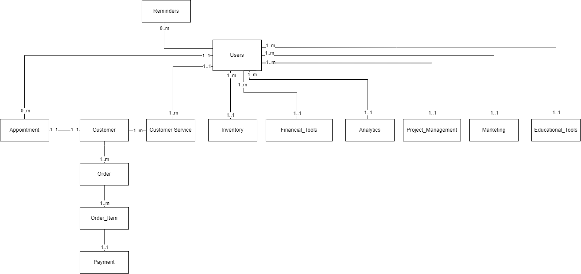

Figure 1.1 Class Diagram

**2.0 Responsibilities**

The Student Business System is a platform designed to support college students in managing their businesses effectively. It offers a range of tools and functionalities tailored to the needs of student entrepreneurs. Now, let's delve into the responsibilities of the classes within the Student Business System, highlighting their roles and functionalities in enabling efficient business management and growth.

1. User:

* Responsible for representing a user of the system.
* It can be a college student, employee, supplier, or customer.
* Has attributes such as name, email, and role.
* Can perform actions like login, logout, and update profile.

1. Inventory:

* Responsible for managing the inventory of products or items.
* Keeps track of each item's available quantity, price, and other details.
* Manage inventory by adding new items, updating item details, and removing items.
* Provides functionalities for generating reports related to the inventory.
* Manage supplier information such as name, contact details, and others.
* Handle the process of placing orders with suppliers.

1. Financial Tools:

* Responsible for handling the financial aspects of the business.
* Manages expenses, income, invoices, and financial reports.
* Supports operations like tracking expenses and generating invoices.
* Provides functionalities such as monitoring business finance.

1. Marketing:

* Responsible for managing marketing and promotional activities.
* Supports functionalities like creating and scheduling social media posts, creating campaigns, targeting specific audiences, and tracking marketing efforts.
* Provides tools for social media marketing, email marketing, and advertising.
* Helps reach a wider audience, attract customers, and increase brand visibility.

1. Project Management:

* Responsible for facilitating project management and collaboration.
* Supports features like task management, file sharing, and team communication.
* Enables seamless coordination among team members or partners.
* Provides tools for creating and assigning tasks, setting deadlines, and monitoring project progress.

1. Analytics:

* Responsible for tracking and analyzing business performance.
* Collects and stores data related to sales, revenue, customer behavior, and other performance metrics.
* Generates reports and visualizations to help in decision-making and identifying growth opportunities.
* Provides insights and trends to monitor the success and growth of the business.

1. Customer Service:

* Responsible for managing customer interactions and providing support.
* Handles inquiries, feedback, and complaints from customers.
* Supports functionalities like ticket management, live chat, and knowledge base.
* Ensures excellent customer service and customer satisfaction.

1. Educational Resources:

* Responsible for providing educational resources and guidance to college students interested in entrepreneurship.
* Offers access to learning materials, courses, workshops, and mentors.
* Helps students acquire new skills and knowledge related to business and entrepreneurship.

1. Appointments:

* Responsible for managing appointments or bookings for service-based businesses.
* Supports functionalities like scheduling appointments, managing calendars, and sending reminders.
* Provides a user-friendly interface for both business owners and customers to schedule and manage appointments.

1. Reminder:

* Responsible for sending timely notifications and reminders to users.
* Helps users stay informed about important events, deadlines, or tasks.
* Supports functionalities like setting reminders, sending email or mobile app notifications, and managing notification preferences.

Each class has its distinct set of responsibilities, contributing to the overall functionality and efficiency of the Student Business System. By fulfilling their specific roles, these classes work together to create a comprehensive and user-friendly platform for college students to manage and grow their businesses effectively.

**3.0 UML Diagram**

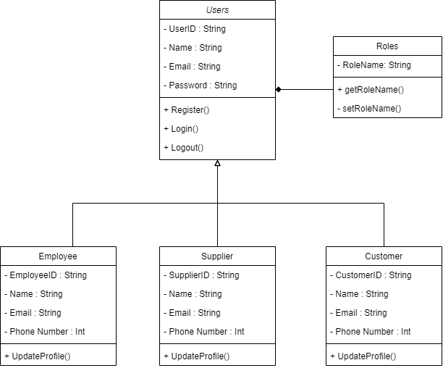

Figure 3.1 UML Diagram

As the problem being considered involves the implementation of the Student Business System with different user roles or permissions, including employees, suppliers, and customers, in order to ensure appropriate access and security of information.

The Decorator Pattern is chosen because it allows for the dynamic and flexible extension of functionality to individual objects at runtime without affecting other objects of the same class. It provides an alternative to subclassing for extending functionality.

In this case, the Users class acts as the base component, representing the common functionalities and attributes of all users. The Roles class serves as the decorator, allowing for the dynamic addition of different roles to the user objects. The Employee, Customer, and Supplier classes act as concrete decorators, adding specific attributes and behaviors to the users based on their assigned roles.

The Decorator Pattern is suitable in this scenario because it allows for the easy addition of new roles in the future without modifying the existing classes. It provides a flexible and scalable solution for handling different user roles and their associated functionalities.